2. Bronze, Music and Liver Cancer

Xiaodong Wang, LAC

So last time I introduce a book called “Emperor’s secret” to you. As the name suggests, it is book owned by people who come from high rank, like the emperor of ancient China. So why do we start today’s topic from the name of the book? Let me tell you something about the importance of bronze first.

In the ancient time, the general publics do not have effective way to produce materials like metal, iron, or even paper. So things like bronze are very valuable materials in ancient time, and it is viewed as a symbol of royalty in the ancient China; in another word, only the emperor have the access to the materials made of bronze. So why does this piece of information have any connection with Acupuncture and Chinese Medicine?

Let me show you two Chinese Writing Characters and one picture of ancient instrument made of bronze, and you will know the answer in a second.

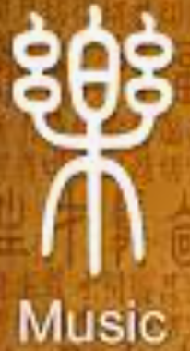 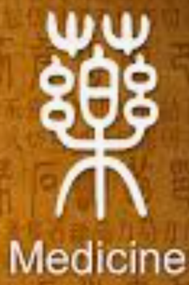 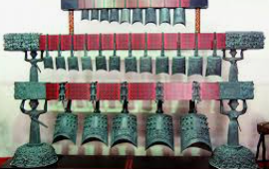

Bingo

See, one picture equals one thousand words

So here is the key point: in the ancient time, the people from high classes already realize music have some therapeutic effect for human, and that is reason of why ancient Chinese characters of music and medicine are so similar, and guess who has the access to a music instrument ? The emperor!!! That is why the book is called the emperor’s secret because he is the only one have the ability to find out this secret.

So music is a very important part in Acupuncture and Chinese Medicine. Ancient people have already practicing music therapy long time ago, but since it is not accessible to the public, it is consider as a part of secret holding by the royalty family.

In ancient China, music is considered as a way of communication between the emperor and the heaven. People believe in playing different tone of sound, the emperor can convey different information to the heaven in order to let the God to maintain the emperor’s health and maintain emperor’s power

Let me share one story with you in order to make our topics more interesting. Don’t worry; I will talk about liver cancer soon.

Story: Once upon a time, there is thief break into a monk’s place and want to steal some food from the kitchen in the midnight. When his hand touches the food on the shelf, he heard someone screaming at him, and he jump his butt right out of the window. After that incident, this brave thief starts to become very timid. One day he saw the monk, and tell the monk what happened. The monk takes him to an ancient bell made of bronze in the midnight, and tells him to wait there. After few minutes, the thief heard the same screaming sound again. The monk tells him this bell will always produce this screaming sound in the midnight. After that, the timid thief become brave again and finally went to jail. Story ends.

Ok, I made up the story, but there is one thing I want to point out here, which is called the “natural resonance”, and it is the reason of why the ancient bell will produce a screaming sound at the middle of the night

So, physically everything one earth have the ability to produce this natural resonance phenomenon as long as the frequency of the force is exactly the natural frequency of the system. Did you ever see some singers can break glassware from just singing frequency of a tone on a talented show?

Sounds very confusing, right? No worries let me explain it in a more friendly way.

Let’s say you want to listen to your favorite radio station, what you would do to a radio? You will adjust the button on the radio machine and change the frequency of the electric wave. If the frequency of the electric wave matches with the frequency from the radio station, your radio machine will produce the same content from the radio studio. The ancient bell in the monk’s house doesn’t produce the screaming sound. The reason of why it makes a screaming sound is because the frequency of electric wave from this bronze bell matches with the frequency of electric wave from the surrounding environment. But why this bell doesn’t make a screaming sound in the daytime? It is because the time is playing a very big role in this event. In the future, we will talk about how the change of time can have influence on people’s health and how can us take advantage of it.

But let’s go back to today’s topic.

Here is the key point in this article: since everything on earth has the ability to produce the natural resonance effect, so does our human body. That means certain frequency of sound can have influence on our own body; furthermore, our human body is very complicated, it contains many organs, and each organ has its own frequency of sound!!! Sounds very crazy right? But it does.

You know you can do something research on your own about how music can help a Parkinson patient restore their moving ability instantly and how music can have effect on your digestion system, it can influence your sleep, your mood and even your blood pressure.

But this article is not about music therapy. I just want to point out that the ancient people have long time ago realize the importance of music, and how can it help patient restore their health or do a clinical diagnosis based on patient’s reaction to a certain sound.

As I stated earlier, in the book of “Emperor’s Secret”, it already assign each human organ with a frequency of sound. And here is relationship: Do for spleen, Re for lung, me for liver, Sol for heart and La for kidney.

And how do we apply this relationship clinically and use this relationship to make clinical diagnosis? I will talk about those technical issues in the future. But for the sake of time, let’s just stop here with an example of liver cancer.

In the future, I will talk about how people can use facial diagnosis on patient to make an educated guess. But I will just give you the answer here. When a person has a liver disease, their face might look a little bit of dirty green color; the middle of their nose, or the peak of their nose, might looks little bit of a bulging shape, it might even have some deep body marks across the bridge of the nose, and both side of their tongue will look unusually reddish. Such kind of a person normally acts very normal and very happy in the public but very sad at home. They normally can be very tallish in the public but very quiet at home. They normally also have some digestion issues, and can hiccup easily.

We should let such kind of a person listen to the sound of Mi and Do at home to relieve their negative emotions and to relieve their digestion issues. Clinically, I will help the patient to course his liver qi and adjusting his digestion system.

Don’t feel puzzled if you don’t know what a liver qi is. I will talk those terms in the future. I just want you know that the ancient people have long time ago pay a lot of attention on music therapy.

Happy Thanksgiving!!!! See you next time